An Internship Report
Of
Data Science Master

Submitted
To
School of Computer Science and Engineering
IILM University, Greater Noida, U.P.

In partial fulfilment of the requirement of degree of
B-Tech (CSE)



By

Roll Number of Student:- 2410030231
Name of Student: Lavanya Sharma

Batch: 2024-28
CANDIDATE'S DECLARATION
I, Lavanya Sharma, hereby declare that the internship report titled “Data Science Master” has been completed by me in partial fulfilment of the requirements for the award of the degree of Bachelor of Technology in Computer Science and Engineering at IILM University, Greater Noida.
This report presents my learning and practical exposure gained during the 8-Week AICTE–EduSkills Virtual Internship Program in the domain of Siemens Data Science Master, conducted from June 2026 to August 2026.
I further declare that the information presented in this report is based on my learning, internship activities, assessments, assignments, and the official internship materials provided during the program. All references used in preparing this report have been appropriately acknowledged.
Signature:-

Student Name: Lavanya Sharma

Roll No.: 2410030231

ACKNOWLEDGEMENT
I would like to express my sincere gratitude to everyone who supported and guided me throughout my internship.
I am thankful to the AICTE–EduSkills Virtual Internship Program and EduSkills for providing me with the opportunity to participate in the Siemens Data Science Master Virtual Internship Program. The structured eight-week curriculum provided valuable exposure to Data Science, Data Engineering, Machine Learning, Data Preparation, Machine Learning deployment and monitoring, and AI platform administration.
I am also grateful to IILM University, Greater Noida, and the faculty members of the School of Computer Science and Engineering for their continuous support and encouragement throughout the internship.
The weekly assessments, assignments, project documentation, and final assessment helped me strengthen my understanding of industry-oriented Data Science and Machine Learning concepts.
Finally, I would like to express my gratitude to my parents and everyone who supported me during this learning journey.
Signature:

Student Name: Lavanya Sharma

Roll No.: 2410030231

TABLE OF CONTENTS
1. Candidate's Declaration i
2. Acknowledgement ii
3. Internship Completion Certificate -
4. Project Description 1
4.1 Introduction 1
4.2 Organization Profile 2
4.3 Problem Statement 3
4.4 Project Objectives 3
4.5 Scope of the Project 4
4.6 Technologies and Tools Used 4
4.7 System Architecture 5
4.8 Methodology 6
4.9 Key projects and demonstrated skills 7
4.10 Expected Outcomes 8
4.11 Certificates of Completion and Communication Proof 8
5. Bibliography/References 9

3. INTERNSHIP COMPLETION CERTIFICATE
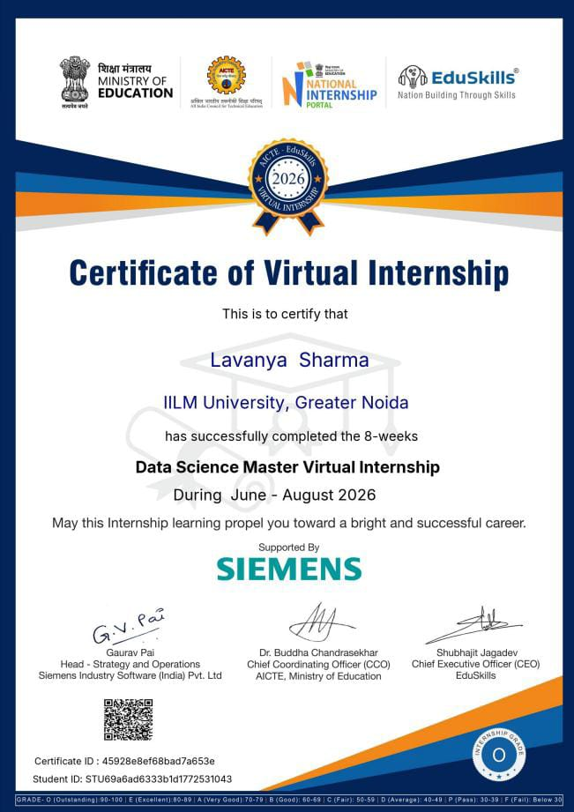

Internship Offer Letter
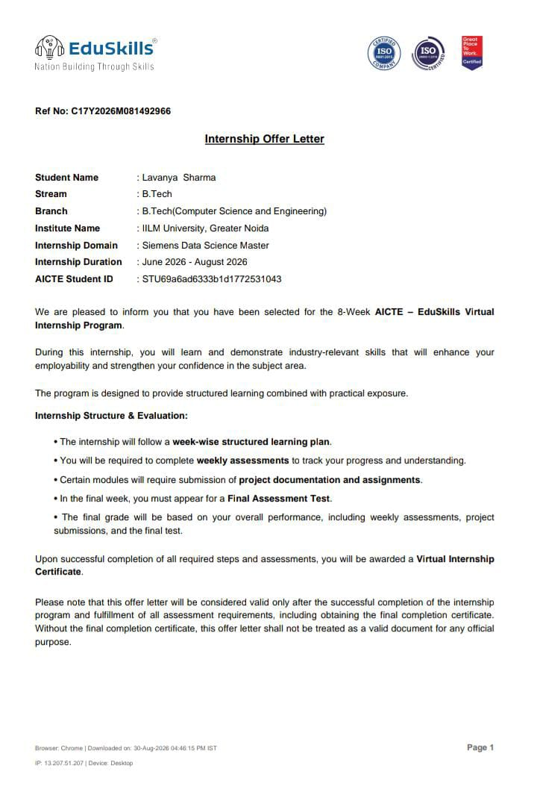

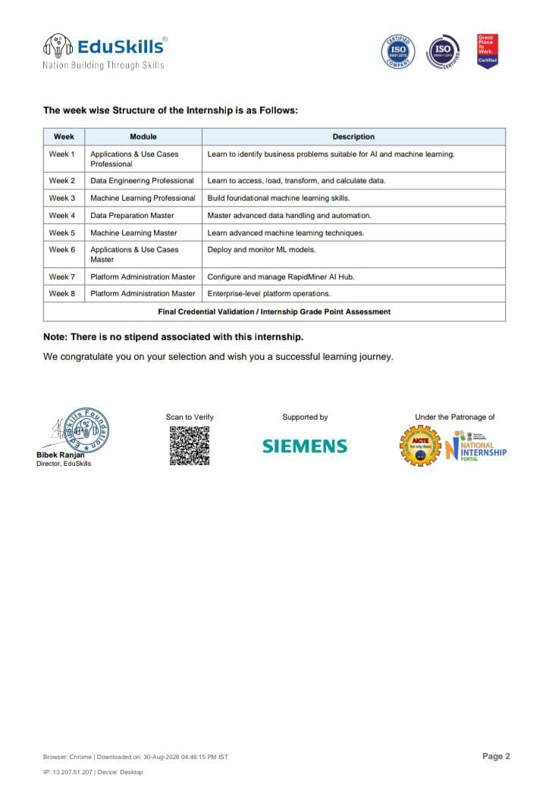

4. PROJECT DESCRIPTION

4.1 Introduction
This report presents a detailed account of the 8-Week AICTE–EduSkills Virtual Internship Program undertaken in the domain of Siemens Data Science Master from June 2026 to August 2026.
The internship was undertaken as part of the Bachelor of Technology in Computer Science and Engineering program at IILM University, Greater Noida. The primary objective of the internship was to develop practical and industry-oriented understanding of Data Science and Machine Learning.
The internship followed a structured week-wise learning approach covering business applications of Artificial Intelligence and Machine Learning, Data Engineering, Machine Learning, advanced Data Preparation, advanced Machine Learning techniques, model deployment and monitoring, and RapidMiner AI Hub platform administration.
The program combined conceptual learning with weekly assessments, assignments and project documentation. A final assessment was also conducted as part of the overall internship evaluation. Successful completion of the required activities and assessments leads to the Virtual Internship Certificate.

4.2 Organization Profile
EduSkills is an organization that provides industry-oriented learning and internship opportunities for students. Through the AICTE–EduSkills Virtual Internship Program, students are provided with structured learning experiences in emerging technology domains.
The internship program is designed to strengthen students' technical knowledge and employability through structured modules, assessments, assignments and practical learning activities.
The present internship was conducted under the Siemens Data Science Master domain. The program focused on developing skills in Data Science, Data Engineering, Machine Learning, Data Preparation, Machine Learning deployment and monitoring, and AI platform administration using RapidMiner AI Hub.
The internship was conducted virtually over a period of eight weeks from June 2026 to August 2026.

4.3 Problem Statement
Modern organizations generate large volumes of data from business operations and digital systems. However, raw data alone cannot provide meaningful business value unless it is properly collected, transformed, prepared, analyzed and used to develop reliable Machine Learning solutions.
A major challenge in the industry is to transform raw and complex data into useful information while developing Machine Learning models that can support business applications. In addition, Machine Learning models need to be deployed, monitored and managed effectively after development.
The internship addresses these challenges by providing structured exposure to the Data Science and Machine Learning lifecycle, including data engineering, data preparation, Machine Learning model development, advanced Machine Learning techniques, deployment and monitoring, and enterprise-level AI platform administration.

Industry Context
Data Science and Machine Learning are increasingly used across industries for data-driven decision-making, prediction, automation and process improvement. Therefore, professionals need knowledge beyond model development, including data preparation, automation, deployment and monitoring.
The internship provides an industry-oriented learning pathway covering these stages and introduces RapidMiner AI Hub for AI platform configuration and management

4.4 Project Objectives
The major objectives of the internship were:
- To understand how Artificial Intelligence and Machine Learning can be applied to business problems.
- To develop an understanding of Data Engineering processes.
- To learn how to access, load, transform and calculate data.
- To develop foundational Machine Learning skills.
- To learn advanced data handling, preparation and automation techniques.
- To understand advanced Machine Learning techniques.
- To understand the deployment and monitoring of Machine Learning models.
- To gain exposure to RapidMiner AI Hub configuration and management.
- To understand enterprise-level AI platform operations.
- To strengthen practical understanding of the end-to-end Data Science and Machine Learning workflow.

4.5 Scope of the Project
The scope of the internship covers major stages of the Data Science and Machine Learning workflow.
The learning begins with identifying suitable business problems for Artificial Intelligence and Machine Learning. It then progresses through Data Engineering, data loading and transformation, data preparation and automation, Machine Learning model development, and advanced Machine Learning techniques.
The internship also covers the deployment and monitoring of Machine Learning models and provides exposure to RapidMiner AI Hub for platform configuration, management and enterprise-level operations.
The scope of the internship is primarily educational and virtual, with learning activities, assessments, assignments and project documentation conducted as part of the AICTE–EduSkills Virtual Internship Program.
4.6 Technologies and MLOps Tools Used
The major technologies, concepts and platforms covered during the internship include:
- Data Science
- Data Engineering
- Data Preparation and Transformation
- Machine Learning
- Advanced Machine Learning Techniques
- Data Handling and Automation
- Machine Learning Deployment
- Machine Learning Monitoring
- RapidMiner AI Hub
- AI Platform Administration
- Enterprise AI/ML Operations
4.7 System Architecture
The overall workflow followed during the internship can be represented as a Data Science and Machine Learning lifecycle:
Business Problem Identification
↓
Data Access & Collection
↓
Data Engineering & Transformation
↓
Data Preparation & Automation
↓
Machine Learning Model Development
↓
Model Evaluation
↓
Model Deployment
↓
Model Monitoring
↓
AI Platform Administration using RapidMiner AI Hub
Each stage contributes to transforming raw data into a usable Machine Learning solution. The workflow demonstrates how Data Science activities progress from understanding a business problem and preparing data to developing, deploying and monitoring Machine Learning models.

4.8 Methodology

Week | Module | Description
Week 1 | Applications & Use Cases Professional | Identifying business problems suitable for Artificial Intelligence and Machine Learning.
Week 2 | Data Engineering Professional | Accessing, loading, transforming and calculating data.
Week 3 | Machine Learning Professional | Developing foundational Machine Learning skills.
Week 4 | Data Preparation Master | Advanced data handling and automation.
Week 5 | Machine Learning Master | Learning advanced Machine Learning techniques.
Week 6 | Applications & Use Cases Master | Understanding Machine Learning model deployment and monitoring.
Week 7 | Platform Administration Master | Configuring and managing RapidMiner AI Hub.
Week 8 | Platform Administration Master | Understanding enterprise-level platform operations.

Each week concluded with a weekly assessment to evaluate conceptual understanding, and selected modules required submission of project documentation and assignments. In the final week, a Final Assessment Test was conducted, and the overall grade was based on performance across weekly assessments, project submissions, and the final test.

4.9 Key Projects & Demonstrated Skills
The internship provided practical learning exposure across different stages of the Data Science and Machine Learning lifecycle.
Key skills demonstrated include:
- Identification of business problems suitable for AI and Machine Learning.
- Understanding of Data Engineering workflows.
- Data access, loading and transformation.
- Data preparation and handling.
- Data automation techniques.
- Development of foundational Machine Learning knowledge.
- Understanding of advanced Machine Learning techniques.
- Understanding of Machine Learning model deployment.
- Understanding of model monitoring.
- Exposure to RapidMiner AI Hub.
- AI platform configuration and management.
- Understanding of enterprise-level AI/ML operations.
- Ability to document learning activities and complete structured assessments and assignments.
The internship helped develop an end-to-end understanding of how data moves from an initial business problem through data preparation and Machine Learning towards deployment, monitoring and platform management.

4.10 Expected Outcomes
Upon completion of the internship, the following learning outcomes were achieved:
- Improved understanding of Data Science and Machine Learning concepts.
- Understanding of the Data Engineering and Data Preparation lifecycle.
- Ability to identify suitable business applications for AI and Machine Learning.
- Understanding of Machine Learning model development and advanced techniques.
- Understanding of Machine Learning deployment and monitoring.
- Exposure to RapidMiner AI Hub and AI platform administration.
- Improved understanding of enterprise-level Machine Learning operations.
- Development of practical and industry-oriented Data Science skills.
- Improved ability to document, present and communicate technical work.

4.11 Certificates of Completion and Communication Proof
The Internship Offer Letter and the Internship Completion Certificate issued by EduSkills Academy, confirming successful completion of the 10-weeks AICTE – EduSkills Virtual Internship Program in AI Deployment & Automation, are attached in Chapter 3 of this report.

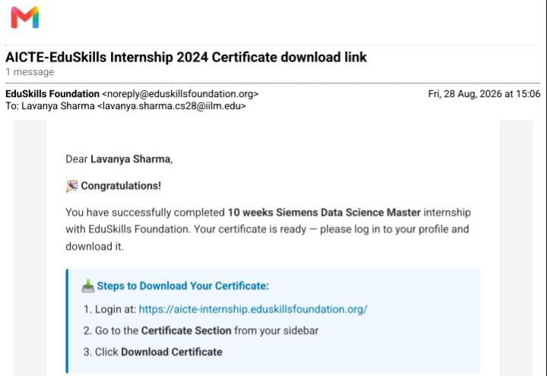
5. BIBLIOGRAPHY/REFERENCES
- EduSkills Academy, AICTE–EduSkills Virtual Internship Program – Siemens Data Science Master, Internship Offer Letter, 2026.
- AICTE–EduSkills Virtual Internship Program, official learning modules and course materials provided during the internship.
- RapidMiner, official documentation and learning resources related to RapidMiner AI Hub.
- Relevant Data Science and Machine Learning learning materials provided as part of the internship program.

